Pumpkins Dataset Graphs Output

- The heaviest pumpkin weighs 2850 lbs, it is a Big Max Pumpkin and was grown in Belgium, Deurle in 2016.
- Pumpkins which weigh 1000lbs and more are classified as Heavy, between 200lbs and 999 lbs they are classified as Medium, and those which weigh below 200lbs are classified as Light.
- Plot estimated vs actual weight (coloured by class)
This is a scatterplot comparing the estimated weight versus the actual weight of each pumpkin in the dataset. Pumpkin weights which are below 200lbs are green, up to 1000lbs are blue, and 1000lbs+ are red. The graph shows a proportional relationship between the estimated and actual pumpkin weight, the estimated weight roughly matches the actual weight, but with some variability and very few (large) inaccuracies i.e. 2 pumpkins estimated weight is 1000lbs-1200lbs but the actual weight is approximately 300lbs.
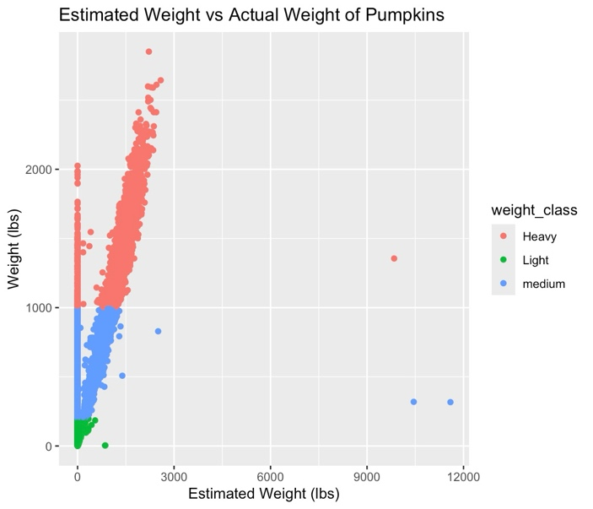

- Summarise mean weights by country and variety (filtered dataset-Italy, Germany, France).
Identify the mean weight of pumpkins for each of your three countries. Which country had the highest mean pumpkin weight?
Italy had the highest mean pumpkin weight - 318kg.
Which variety in which country had the lowest mean weight?
The Big Moose in France had the lowest mean weight - 220kg.
- Create a boxplot for the three countries
The graph shows the distribution of pumpkin weight between countries from the filtered dataset, the median weight seems to be similar across the three countries, and all countries have pumpkin which weigh exceptionally heavier than the median, indicating a widespread. Although Italy has the greatest outliers.
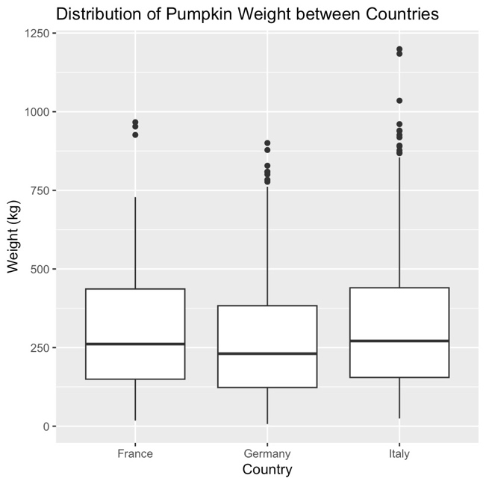

- Create a faceted plot by variety
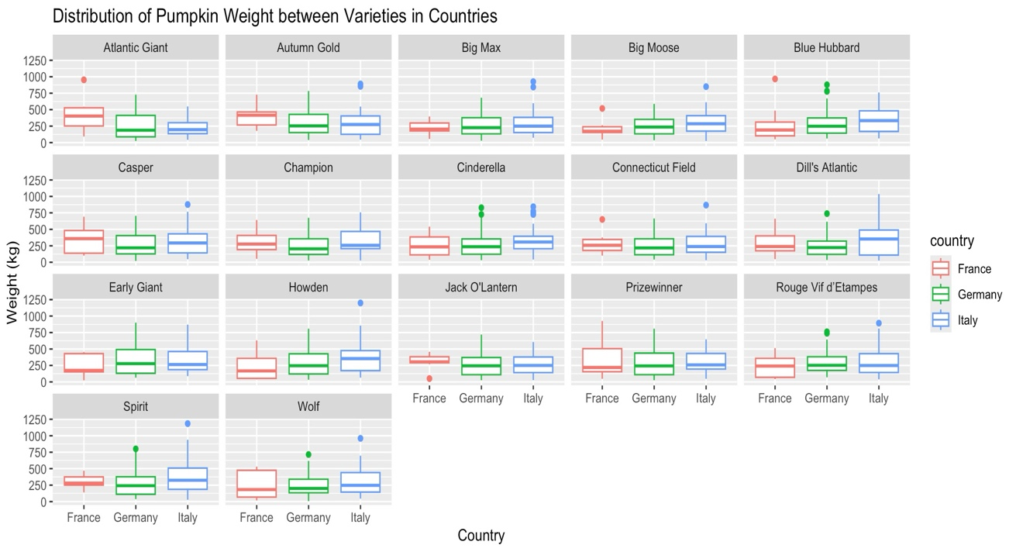
This graph shows the distribution of weight for each variety of pumpkin from all the countries in the filtered dataset. There are outliers present, the median weight in Big Moose, Cinderella, Connecticut Field, Prizewinner, Rouge Vif d’Etampes and Wolf seems to be most similar across the countries. Typically most pumpkins weigh less than 500kg with few exceeding this weight. The colour of each bar indicates a different country.

